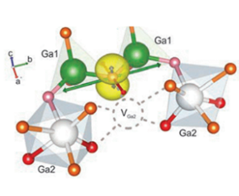
The 1st National workshop

“Gallium Oxide ultra wide band gap material

for energy electronics”

26/01/2023

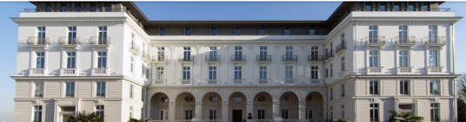
la Délégation CNRS « Ile de France Ouest et Nord » Meudon

9H00: Salle Isadora Duncan Welcome coffee
9H00-9H50 guided visit (by 2 groups) of historical “Geant of Bellevue”
10H: Ga₂O₃ activity in GEMaC, Corinne Sartel, and Ekaterine Chikoidze CNRS, UPSa
10H20: Zn doping effect in Ga₂O₃ and beyond, Zeyu Chi, GEMaC, CNRS, UPSa
10H40: Acceptor defects in Ga₂O₃ - an overview of EPR results, Jurgen von bardeleben, Institut des Nanosciences de Paris, Sorbonne Université
11H00: Spectroscopie électro-optique des défauts profonds dans les semi-conducteurs grands gaps: Application à l'oxyde de gallium, Georges Bremond, Institut des Nanotechnogies de Lyon
11H20: Chemical Synthesis of Ga₂O₃ Materials in LMGP, LMGP
11H40: Two-dimensional hole conductivity and compensation in Ga₂O₃, Tamar Tchelidze, Ivane Javakhishvili State University, Georgia
12H10-13H20: Lunch
13H30: Advanced electrical characterization techniques applied to study β- Ga₂O₃ Schottky barrier diodes, Philippe Ferrandis , Institut Néel
13H50: Link between polishing cycles and surface defects in β- Ga₂O₃ diodes grown on floating zone substrates, Coralie Perrier, Institut Néel
14H10: "Tuning the Ga2O3 band alignment using a HfZrO4 ferroelectric layer,Anthony Boucly
, IRAMIS,CEA
14H30: Doping effect of elementary defects produced by irradiation of Ga₂O₃ with relativistic electrons,
Marcin Konczykowski, LSI, Polytechnique
14H50: Control of charge states of Cr and Fe impurities in Ga₂O₃ by irradiation with relativistic electrons, Slava Safarov, LSI, Polytechnique
15H10 :Ga₂O₃ Thin Films by Pulsed Laser Deposition for Improved Energy Conversion Efficiency in Electronics, Sensors and Solar Cells. David Rogers, Nanovation
15H30-16H30: Discussion

 | Corinne Sartel | corinne.sartel@uvsq.fr | GEMaC, CNRS, UPSa
 | Ekaterine Chikoidze | Ekaterine.chikoidze@uvsq.fr | GEMaC, CNRS, UPSa
 | Zeyu Chi | zeyu.chi@uvsq.fr | GEMaC, CNRS, UPSa
 | Yves Dumont | Yves.dumont@uvsq.fr | GEMaC, CNRS, UPSa
 | Vincent Sallet | vincent.sallet@uvsq.fr | GEMaC, CNRS, UPSa
 | Soroush Abbasi | alain-soroush.abbasi-zargaleh@uvsq.fr | GEMaC, CNRS, UPSa
 | Mathieu Fregnaux | mathieu.fregnaux@uvsq.fr | ILV, CNRS, UPSa
 | Jurgen von Bardeleben | vonbarde@insp.jussieu.fr | INSP, CNRS,Paris Sorbonne
 | Jean-Louis Cantin | cantin@insp.jussieu.fr | INSP, CNRS, Paris Sorbonne
 | Yunlin Zheng | zheng@insp.upmc.fr | INSP, CNRS,Paris Sorbonne
 | Jean-Marie Bluet | jean-marie.bluet@insa-lyon.fr | INL, INSA
 | Georges Bremond | georges.bremond@insa-lyon.fr | INL, INSA
 | Philippe Ferrandis | philippe.ferrandis@neel.cnrs.fr | Institute Néel
 | Coralie Perrier | coralie.perrier@neel.cnrs.fr | Institute Néel
 | Nick Barrett | nick.barrett@cea.fr | DRF/IRAMIS/SPEC,CEA
 | Christophe Lubin | christophe.lubin@cea.fr | DRF/IRAMIS/SPEC,CEA
 | Anthony Boucly | anthony.boucly@cea.fr | DRF/IRAMIS/SPEC,CEA
 | David Rogers | rogers@nanovation.com | Nanovation
 | Vincent Consonni | vincent.consonni@grenoble-inp.fr | LMGP
 | Tamar Tchelidze | tchelidze@tsu.ge | TSU, Georgia
 | Henri-Jean Drouhin | henri-jean.drouhin@polytechnique.edu | LSI, Polytechnique
 | Marcin Konczykowski | marcin.konczykowski@polytechnique.edu | LSI, Polytechnique
 | Slava Safarov | visafarov@gmail.com | LSI, Polytechnique

